Project Design Phase-II
Data Flow Diagram & User Stories

Date | 23 February 2026
Team ID | LTVIP2026TMIDS76018
Project Name | Rising waters: a machine learning approach to flood prediction
Maximum Marks | 4 Marks

Data Flow Diagrams:
The Flood Prediction System is a machine learning–based web application developed to predict the possibility of floods using environmental parameters such as temperature, humidity, rainfall and cloud cover. The system takes user input through a web interface, processes the data using a trained machine learning model and displays the prediction result.
The application is built using Python, Flask framework and an XGBoost machine learning model. The trained model and scaler are stored as files and used during prediction.

DFD Level 0 (Context Diagram)
The Level 0 Data Flow Diagram represents the overall working of the flood prediction system. It shows how the external user interacts with the system and how the system provides predictions.
The user enters environmental parameters through the web interface. These inputs are sent to the flood prediction system. The system processes the data using the trained machine learning model and returns the output as flood risk prediction.
The trained model file and scaler file act as data storage components. They are used by the system to process input data and generate accurate predictions.

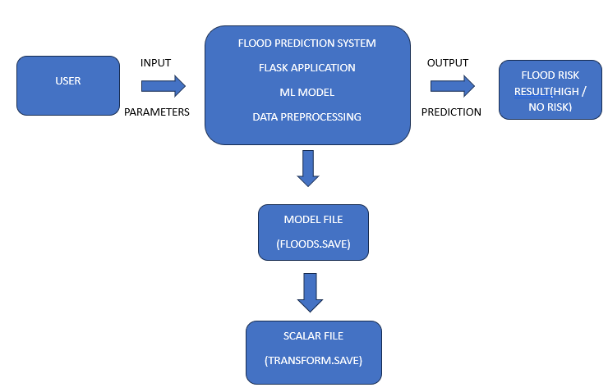
DFD Level 1
The Level 1 Data Flow Diagram explains the internal working of the system in detail.
- The user enters environmental values such as rainfall, humidity and temperature in the web form.
- The Flask web application receives the input data.
- The input data is passed to the preprocessing module where the StandardScaler transforms the values.
- The processed data is given to the trained machine learning model.
- The model predicts whether there is a flood risk or not.
- The prediction result is displayed on the result page.
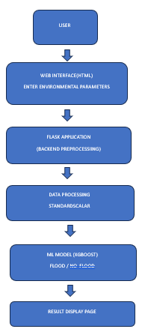

User Stories
Use the below template to list all the user stories for the product.
User Type | Functional Requirement (Epic) | User Story Number | User Story / Task | Acceptance criteria | Priority | Release
Customer (Web user) | Registration | USN-1 | As a user, I can access the Flood Prediction web application to enter environmental parameters. | User should be able to open the home page and navigate to prediction page. | High | Sprint-1
 | Prediction | USN-2 | As a user, I can enter temperature, humidity, rainfall and other parameters to check flood risk. | should accept valid numerical inputs and prevent empty submission | High | Sprint-1
 | Prediction Result | USN-3 | As a user, I can click the Predict button to generate flood risk results. | System should display either “High Flood Risk” or “No Flood Risk” | High | Sprint-1
 | Model Processing | USN-4 | As a user, I want the system to process my data using a trained machine learning model. | Input data must be scaled using Standard Scaler before prediction. | Medium | Sprint-1
 | Result Display | USN-5 | As a user, I want to clearly view the prediction result on a separate result page | Result page must display prediction clearly with proper message | High | Sprint-1
Customer Care Executive | Monitoring | USN-6 | As an executive, I want to understand how predictions are generated to assist users. | System should use saved model file (floods.save) and scaler (transform.save). | Medium | Sprint-2
Administrator | Model Management | USN-7 | As an administrator, I want to update the trained model if new data is available. | System should allow replacement of model file without breaking application. | Medium | Sprint-2
 | System Maintenance | USN-8 | As an administrator, I want to maintain and monitor the Flask application. | Application should run on localhost without server errors | Medium | Sprint-2

